* **Welcome to Home Page**, with 3 options Admin login, User Login and Search Available flights,

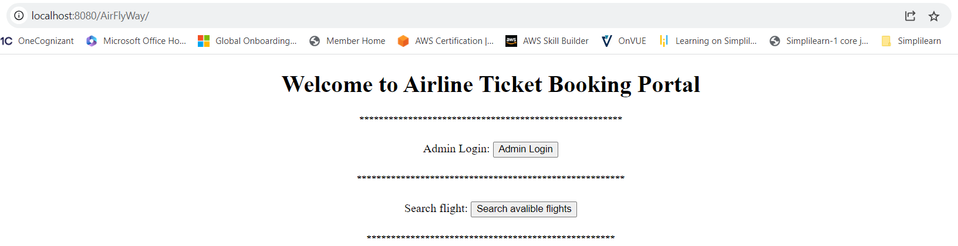

* Let’s go with **option 1 : Admin login,**

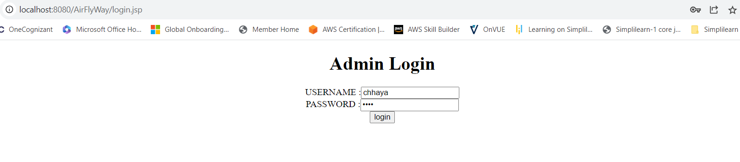

* When Admin enter **incorrect username or password**, its shows:

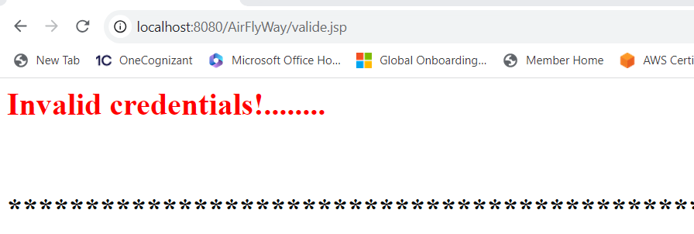

* When Admin **correct username and password**, it is allowed Display admin level operations:

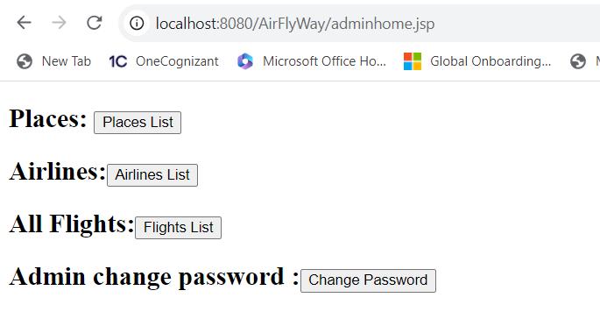

* When you admin click on **Places** , its show all available places :

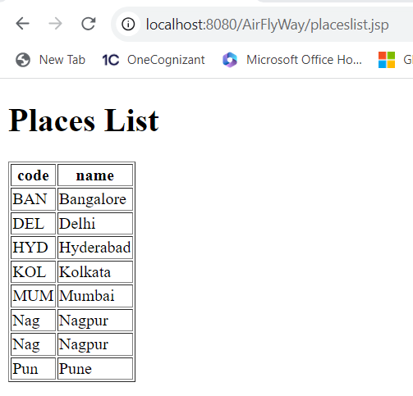

* When you admin click on **Airlines** , its show all available Airlines :

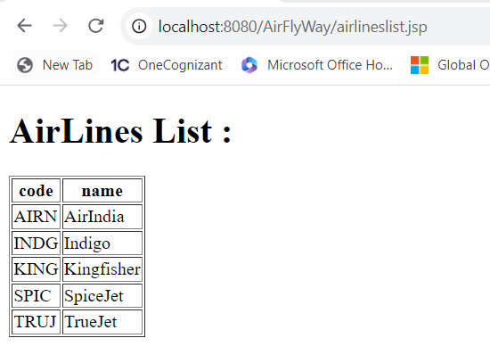

* When you admin click on Change Password , its allow admin to change old password with new password:

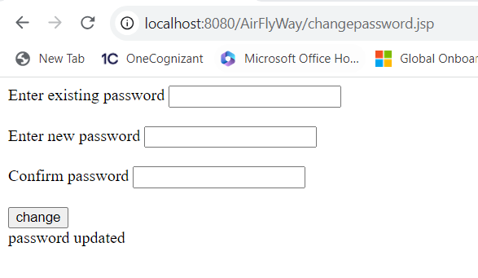

* When you admin click on All Flights , its show all available Flights with thier prices :

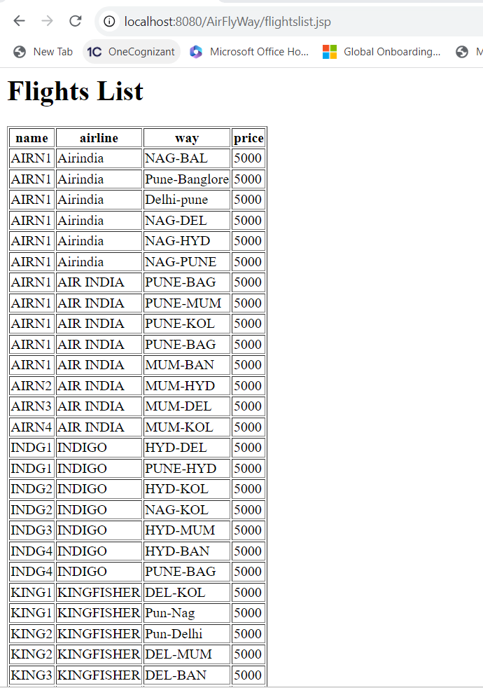

* **All admin level operation are performed**, it’s time to go back main menu to perform other operations:



* Let’s go with **option 2: Search Available Flights,**

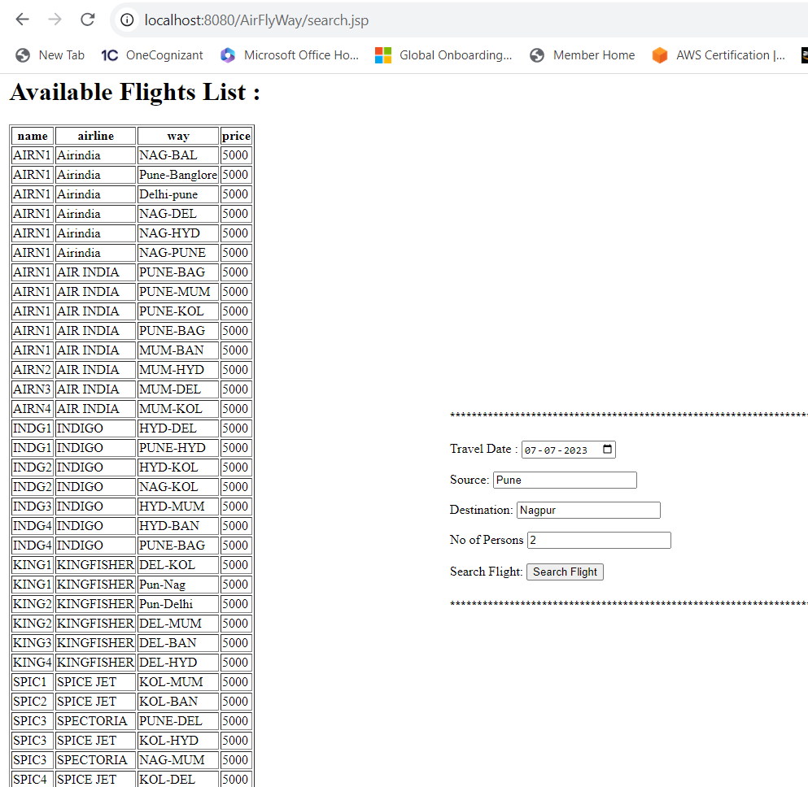

* After clicking on search flight, it’s shows your available flights for respective source and destination. also, its show user registration form:

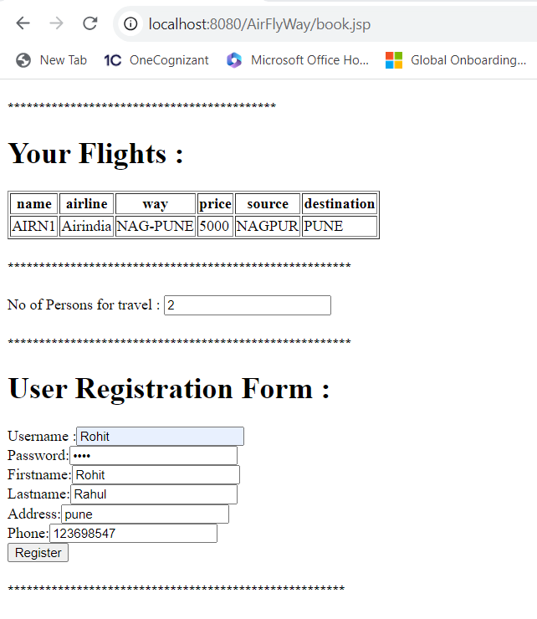

* After Registration its allow your enter number of passenger details and book your ticket:

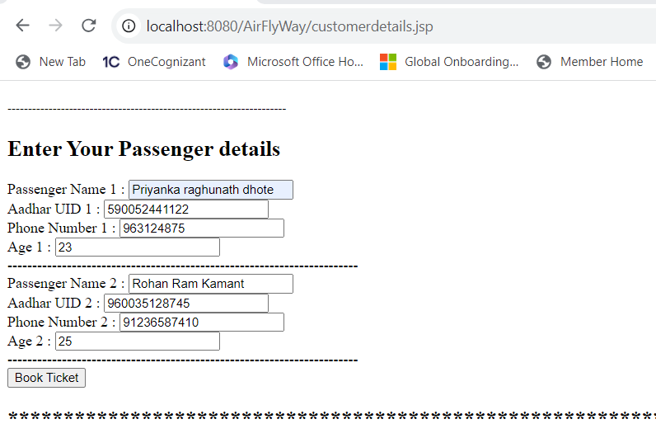

* After clicking on book ticket, it allows you enter your payment details. 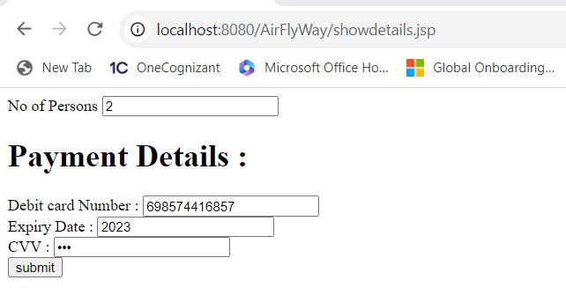
* Once payment done your flight ticket booking successful:

